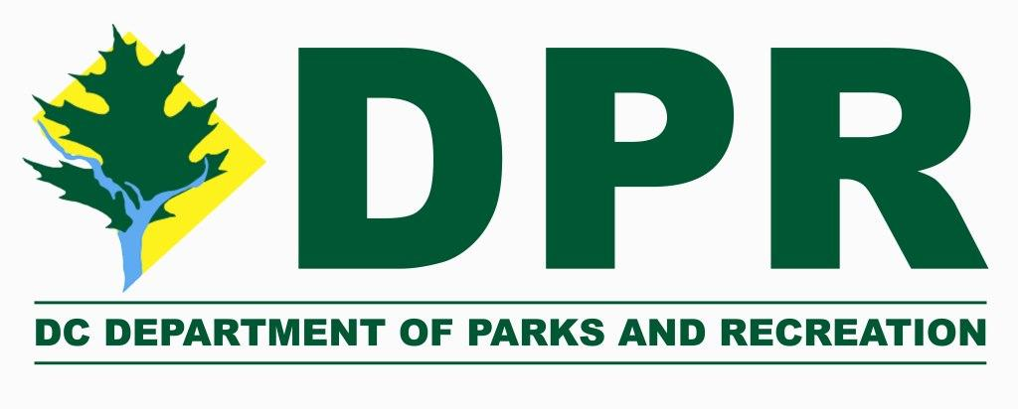
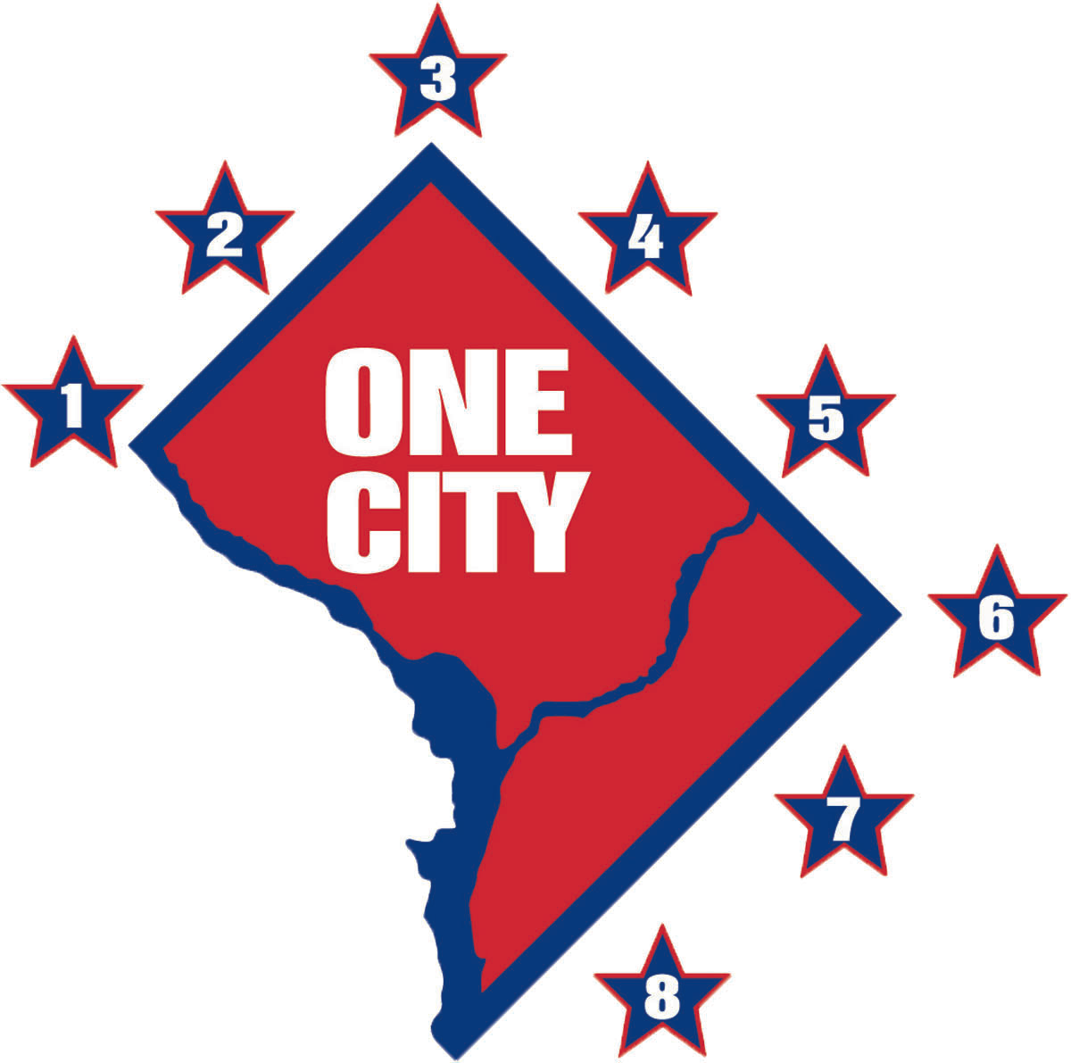

‘Friends’ Park Partner Application

Date:
Contact Name:
Organization Name:
Organization Mailing Address:
City: State: Zip:
Phone Number:
Email Address:
Park or Recreation Site: Ward:
Address of Park or Recreation Site:

‘Friends’ groups are required to be incorporated in the District of Columbia
What is your Employee Identification Number?
Please attach your Articles of Incorporation
Please attach a recent Clean Hands Certificate from DCRA

‘Friends’ groups are required to be 501(c)(3) non-profit organizations whose mission includes supporting the park or recreation site. Please provide your organizations Mission Statement (2,000 Character Maximum)
Please attach a copy of your IRS letter of determination.

Please describe the desired role of your organization in enhancing the park or recreation site. What are your goals for the site, how do you intend to go about reaching them? (5,000 Character Maximum)

What is your organizations strategy for engaging the larger community in your efforts at the park or recreation site? (5,000 Character Maximum)
Please attach a letter of support from your Advisory Neighborhood Commission stating that you have presented the ideas and intentions outlined in this application at an ANC meeting, and that the ANC has passed a resolution recognizing your group as the official community representative for the park or recreation site. The letter must be dated within 3 months of the date of application and be from the full ANC, not the Single Member District.

Please describe your organizations plan for beautifying, improving and maintaining the park or recreation site. What kind of work do you intend to do? What is your timeline or schedule for the work? (5,000 Character Maximum)

Please describe how your organization intends to raise funds for projects, programs and activities at the park or recreation site, including a quarterly timeline. Please be specific as to which activities will take place on site. (5,000 Character Maximum)

